Quick and Dirty Notes for Maddie

It is looking less likely to me that the interference patterns contain strain information, though I don’t know enough about optics to have anything like a definitive opinion. However, I’ve been reasoning that if the interference patterns contain strain information, they should exhibit some sort of periodic fluctuation on the period of the moire superlattice. This is about 4 pixels in real space or so, from what I understand. So my idea was that if we plot the position of the interference pattern “rods” against their real space pixel number, we would expect strain information if the graph exhibits a periodicity of 4, and not otherwise.

There are tons of assumptions and choices behind both my data analysis method and this particular line of reasoning, but it’s the best I can think of when we don’t actually have visible disks to resolve.

Here are a couple of representative plots for how I’m detecting the rods in the diffraction patterns, which was a bit tricky. I’m looking at regions like the following:

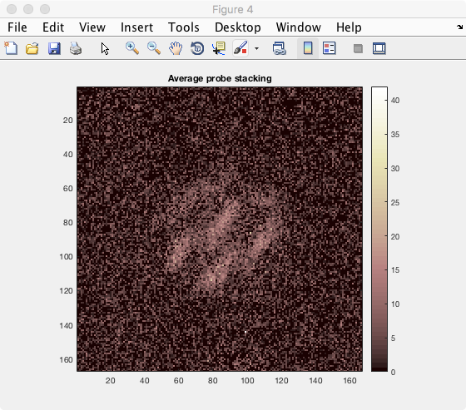

Essentially I worked out a way to average all of the rods over many diffraction patterns to create a template rod (there may be room for improvement here):

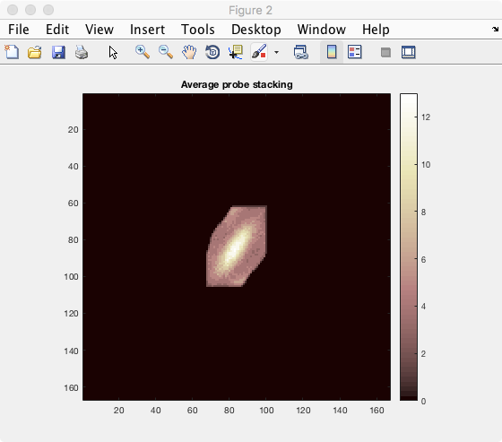

Next, I used this template rod to detect the positions of the rods in the various diffraction patterns. You’ll notice that success is mixed, but this stems particularly from the variation in the interference patterns themselves.

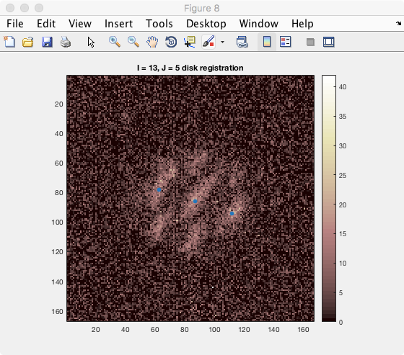

(quite good)

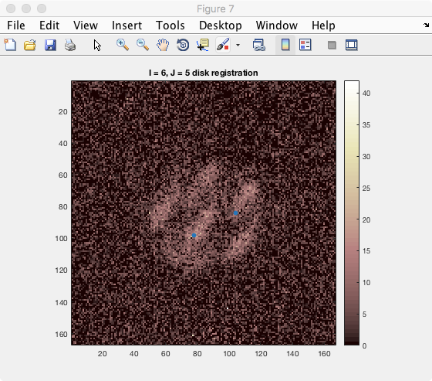

x-coordinate registration might be okay, but y-coordinate is terrible.

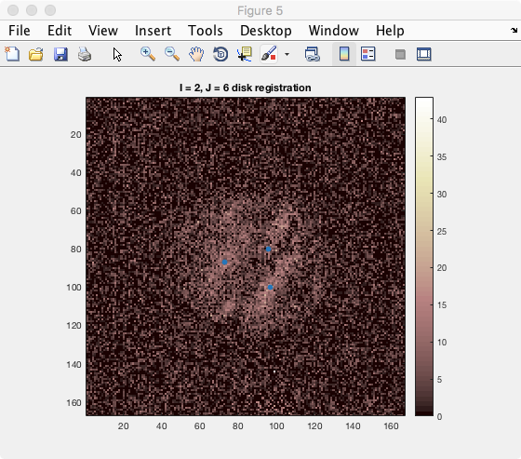

In-between

Then, as discussed above, I find the x and y pixel coordinates of the detected locations. I then restrict myself to a line in real space, moving across the probe scanning area. For I=2 pinned, this means I took only the second row of the dataset in real space, and asked how the x-coordinates of the interference rods moved as we moved in space:

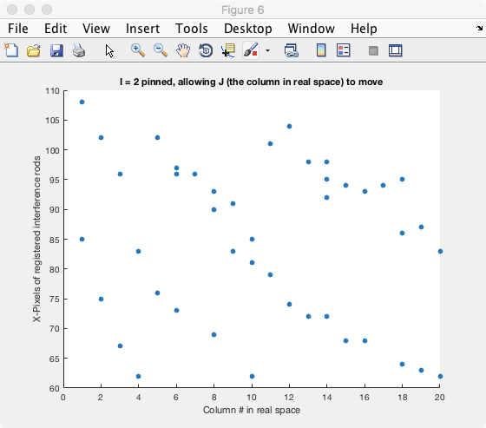

To my eyes, there isn’t any four-fold periodicity as I would have predicted if the interference patterns told us something about strain. Interference rod detection is fairly good when moving in the x-direction. Rods move approximately in lines as expected (indeed, as you can see by scrolling through the data manually in py4DSTEM).

In the y-direction, on the other hand, the graph looks like nonsense. But given some of the examples we have seen above, this stems just from it being hard to detect the y-coordinate for these skinny rods.

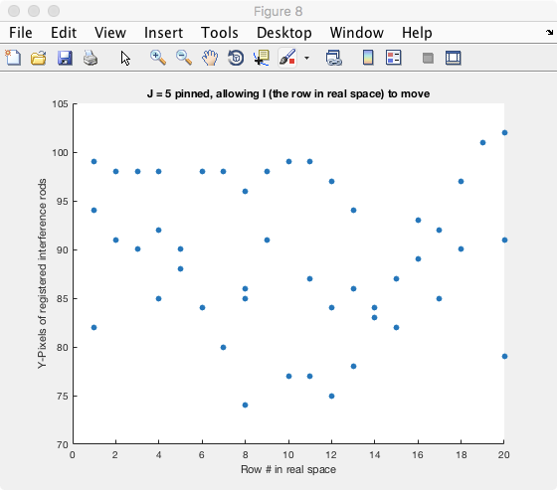

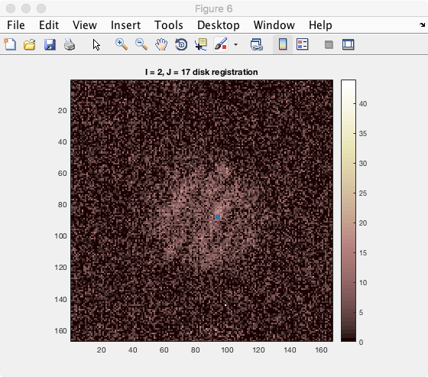

(We only have one rod, but many of the others are very week here)

Okay it’s 2:38am and I’m going to bed. Let’s talk soon about your new set of data collection and where to go from here on the data analysis side.